|  |  |
| --- | --- |
|  | Assignment 1 |
|  | **EECS 2011 – Fundamentals of data structures.** |
|  | **Rajkumar Balakrishnan Lakshmi - 213141197**  9/29/17 |

**Problem 1. [32%] - Finding a duplicate in a preconditioned array**

For this question, I used the process of negating the elements absolute position. By this way I can easily find if an integer is being repeated. I was abled to attain the output for this question due to two main reasons, one is the input must always satisfy the pre-condition that the elements of the array should be in the range 1...n. This makes it possible for the code work properly as I tend to negate the values in the absolute position of the array elements, so there will always be an absolute position of the element I am trying to negate. The second reason is that, I can change the input array which happens in my algorithm.

Example:

input: {6, 2, 1, 6, 4, 5} output: **6**

Code Assertion:

Round 0: i=0, ints[0]=6, result=-1,

ints[(Math.*abs*(ints[6]))-1 = **5** check if the value in it is negative, if not negate it, so the above becomes ints[(Math.*abs*(ints[6]))-1 = **-5**

Round 1: i=1, ints[1]=2, result=-1,

ints[(Math.*abs*(ints[2]))-1 = **2** check if the value in it is negative, if not negate it, so the above becomes ints[(Math.*abs*(ints[6]))-1 = **-2**

Round 2: i=2, ints[2]=1, result=-1,

ints[(Math.*abs*(ints[1]))-1 = **6** check if the value in it is negative, if not negate it, so the above becomes ints[(Math.*abs*(ints[6]))-1 = **-6**

Round 3: i=3, ints[3]=6, result= **6**,

ints[(Math.*abs*(ints[6]))-1 = **-5** check if the value in it is negative, if not negate it, so the above becomes ints[(Math.*abs*(ints[6]))-1 = **5** in this case we found a value that is already neagtive, which means that the original element of it is being repeated, thus we break the loop and return the result.

By this algorithm at any given input that satisfies the pre-condition the desired output will be achieved. Time complexity = o(n) & Space = 0(1).

**Test Cases:**

Input:

**public** **static** **void** main(String[] args)

{

System.***out***.println("Let's test findDuplicate on some arrays: \n ");

// TEST 1:

*testDrive*(**new** **int**[] { 5, 2, 10, 7, 4, 9, 3, 6, 1, 8 }, " -1 ");

// TEST 2:

*testDrive*(**new** **int**[] { 10, 8, 5, 2, 6, 4, 9, 2, 7, 1 }, " 2 ");

// TEST 3:

*testDrive*(**new** **int**[] { 8, 4, 9, 5, 2, 4, 10, 6, 2, 1 }, " 4 , 2 ");

System.***out***.println("\nAdditional tests done by the student or TA:\n");

// TEST 4:

*testDrive*(**new** **int**[] { 3, 6, 8, 9, 4, 5, 2, 1, 7}, " -1 ");

// TEST 5:

*testDrive*(**new** **int**[] { 6, 2, 1, 5, 4, 6}, " 6 ");

// TEST 6:

*testDrive*(**new** **int**[] { 3, 6, 3, 6, 4, 5, 4, 5, 7}, " 3 , 6 , 4 , 5 ");

}

Output:

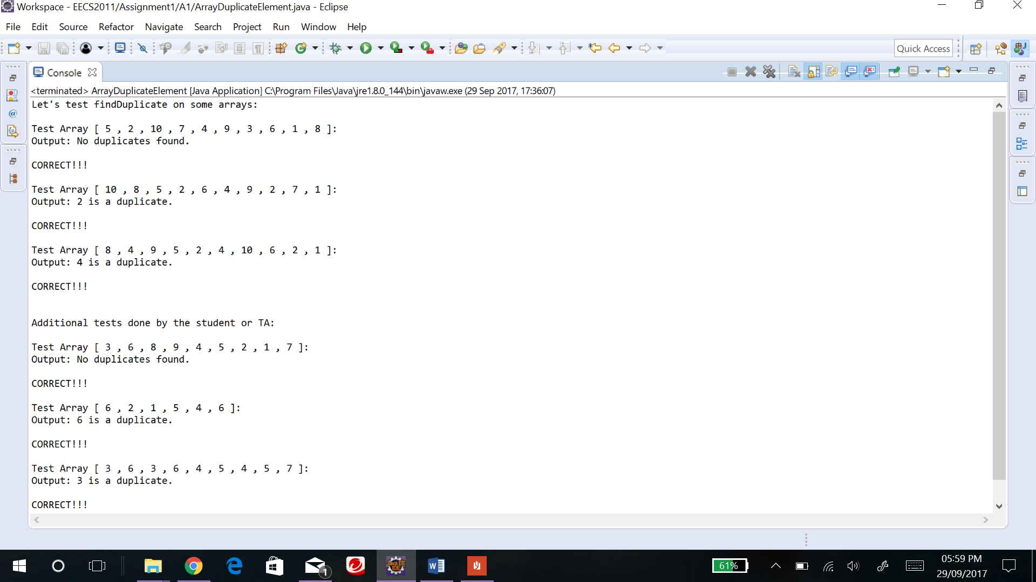

**Problem 2. [36%] - Longest Almost Flat Subarray**

The input here is array of integers ranging between 0 and n-1. I have used a while loop that scans through the array of integers with the condition “**while** (i < ints.length && (i+1) < ints.length)” i.e., it iterates through the array until it reaches the boundary of the array only once. There are temporary variables initial and length initialized to zero and one, that keeps track of the initial and length of flat arrays if any. This is achieved through if-else statement that checks if two continuous elements are either equal or has a difference of 1 and less than or equal to a max value. For the first time the max value is initialized to the length of the array, and it remains same if two continuous elements are equal (e.g. 1,1). The max value gets updated if two continuous elements have difference 1(e.g. 1, 2, max=2). Now, if a flat array is found the values of initial and length gets updated to the longest values, else remains same. By this manner 80% problem gets resolved and provides the right output. In case of an array like the below,

{7, 7, 2, **8, 7, 7, 8, 8, 8, 9, 9, 8, 9, 9**, 6, 8} the underlined green 8 can be considered for both **red** and **purple** numbers. The output should be the flat array {**8, 8, 8, 9, 9, 8, 9, 9}** but with the above algorithm returns {**8, 7, 7, 8, 8, 8}** as output, since the iteration occurs element by element and only once. Thus, to resolve this I introduced another variable sublength initialized to one and it keeps track of the repetition of the max value only at the end of a flat array. The sublength value makes changes to the initial and length values only if the first element next to the end of a flat array is max+1 and sublength is greater than 1. For e.g. in the above case in first flat array max=8 and the first element next to the end of flat array is max+1(9), hence the sublength will be added respectively. This way I could solve the above issue and obtain the right output.

Example: Input Assertion -

Input: {7, 2, 8, 7, 7, 8, 8, 8, 9, 9, 8, 9, 9, 2} output: **[initial, length]**

Initial values:initial=0, length=1, max=0, sublength=1

Round 0: Input: [7!=2]

initial=0, length=1, max=14, sublength=1

Round 1: Input: [2!=8]

initial=0, length=1, max=0, sublength=1

Round 2: Input: [8-7=1]

initial=2, length=2, max=8, sublength=2

Round 3: Input: [7=7]

initial=2, length=3, max=8, sublength=1

Round 4: Input: [7-8=1]

initial=2, length=4, max=8, sublength=1

Round 5: Input: [8=8]

initial=2, length=5, max=8, sublength=2

Round 6: Input: [8=8] output: [2,6]

initial=2, length=6, max=8, sublength=3

End of flat array

New round values:initial=current position- sublength, length=sublength+1, max=14, sublength=1

Round 7: Input: [8-9=1]

initial=5, length=4, max=9, sublength=1

Round 8: Input: [9=9]

initial=5, length=5, max=9, sublength=2

Round 9: Input: [9-8=1]

initial=5, length=6, max=9, sublength=1

Round 10: Input: [8-9=1]

initial=5, length=7, max=9, sublength=1

Round 11: Input: [9=9] **output: [5,8]**

initial=5, length=8, max=9, sublength=2

Round 12: Input: [9!=2]

initial=13, length=1, max=9, sublength=1

**Test Cases:**

Input:

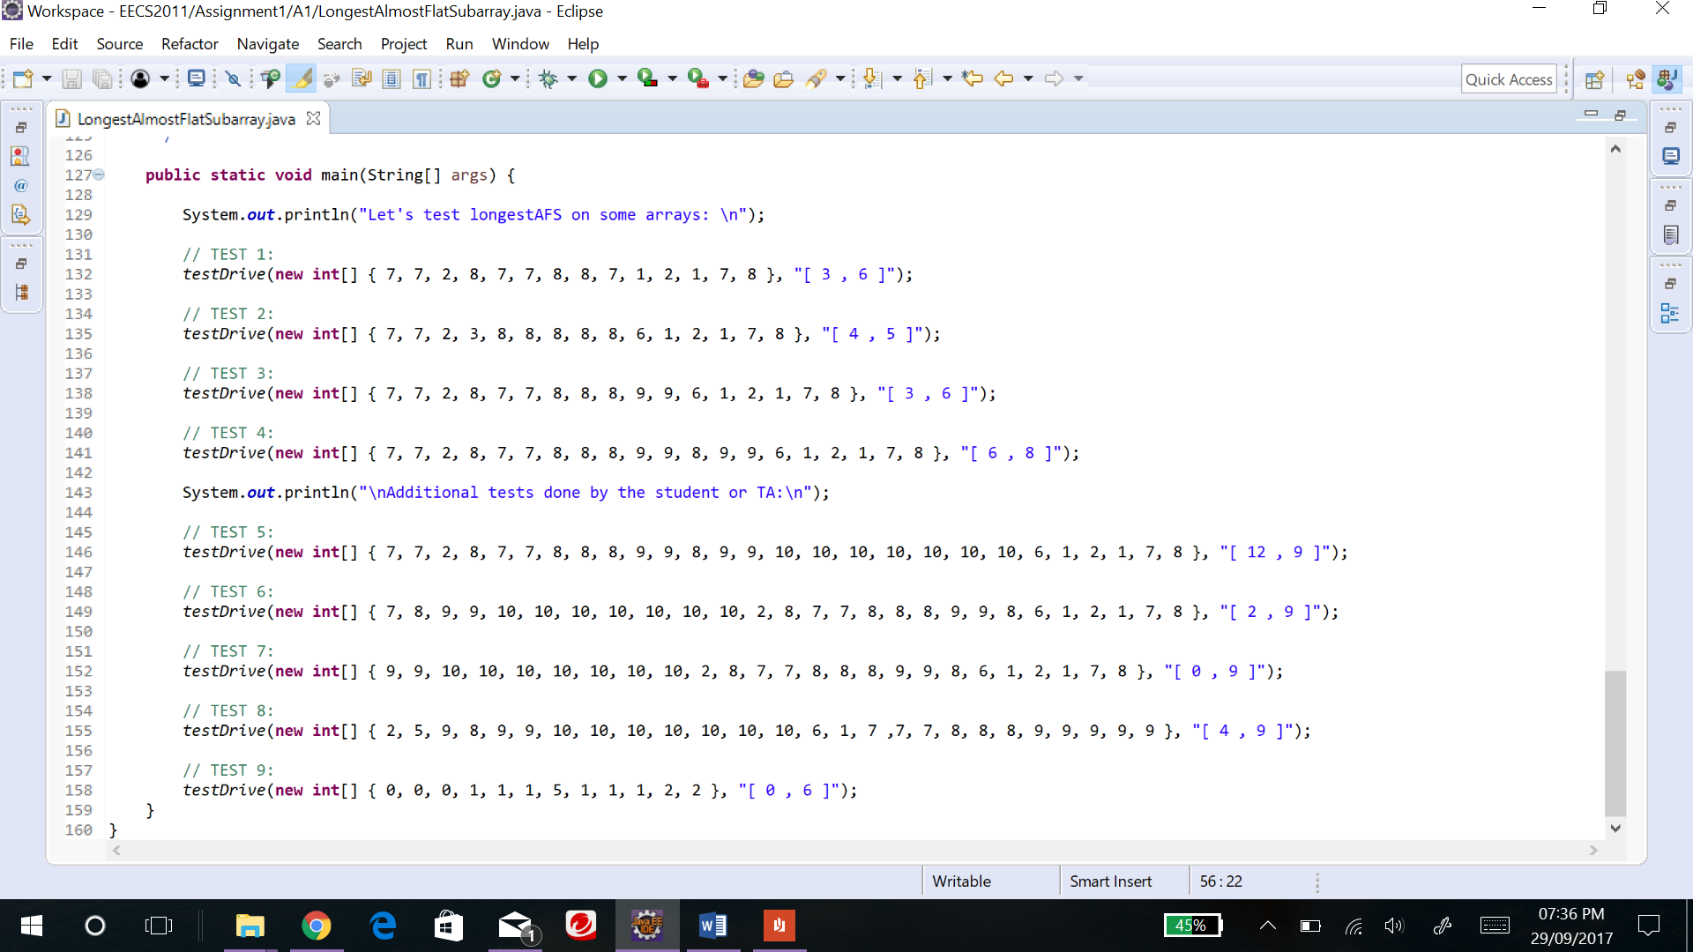

Output:

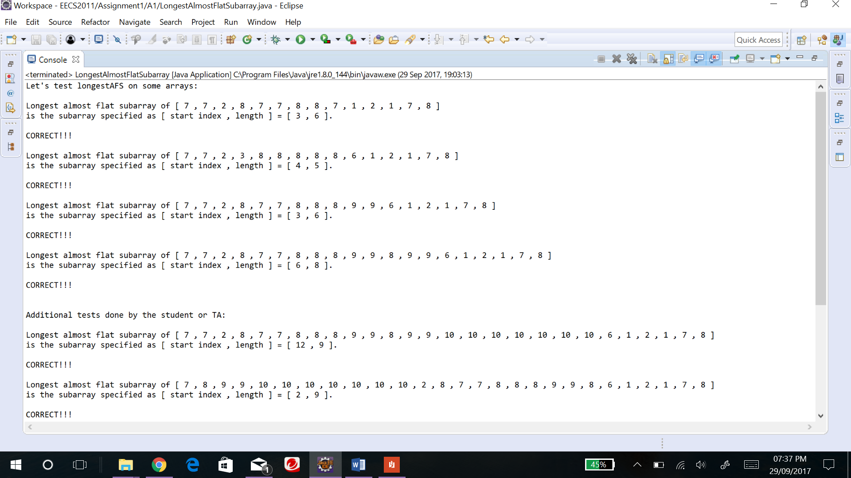

**Problem 3 . [32%] A Hierarchy of Planar Shapes**

For this question I just created the classes and their related methods as shown in the UML diagram.

**Class Ellipse**

Area () - This is an overridden method implemented from the PlanerShape interface, that calculates and returns the area of an ellipse. I calculated the area using the formula

Contains (Point) - This is an overridden method implemented from the PlanerShape interface, that finds if a given point lies within the ellipse. I calculated this using the formula provided in the question.

**Test Cases:**

Input1:

**public** **static** **void** main(String[] args) **throws** InvalidShapeException

{

Point2D.Double centre = **new** Point2D.Double(0,0);

Ellipse e = **new** Ellipse(15.00,30.00, centre);

Point2D.Double point = **new** Point2D.Double(4,2);

System.***out***.printf("%.2f\n",e.area());

System.***out***.println(e.contains(point));

Point2D.Double point2 = **new** Point2D.Double(17,15);

System.***out***.println(e.contains(point2));

System.***out***.println(e.toString());

}

Output1:

1413.72

true

false

Ellipse [Centre = (0.0,0.0), Horizontal_Axis = 15.0, Vertical_Axis = 30.0]

Input2:

**public** **static** **void** main(String[] args) **throws** InvalidShapeException

{

Point2D.Double centre = **new** Point2D.Double(0,0);

Ellipse e = **new** Ellipse(-15.00,30.00, centre);

}

Output2:

Exception in thread "main" A1.InvalidShapeException: Invalid entry! Negative ellipse axis has been entered

at A1.Ellipse.sethAxis(Ellipse.java:71)

at A1.Ellipse.<init>(Ellipse.java:48)

at A1.Ellipse.main(Ellipse.java:164)

**Class Circle**

Area () - This is an overridden method implemented and inherited from the parent class, that calculates and returns the area of a circle. I calculated the area using the formula .

Contains (Point) - This is an overridden method implemented and inherited from the parent class, that finds if a given point lies within the circle. I calculated this in the similar way as that of ellipse, since circle can be considered an ellipse.

Contains (circle) - This method I used to check if a circle exists inside another circle. I verified this using the formula,

Math.*sqrt*((Math.*pow*((**this**.center.x-c.center.x), 2)) + (Math.*pow*((**this**.center.y - c.center.y), 2))) <= (Math.*abs*(**this**.radius-c.radius)));

Input1:

**public** **static** **void** main(String[] args) **throws** InvalidShapeException

{

Point2D.Double mainCentre = **new** Point2D.Double(0,0);

Circle mainCircle = **new** Circle(5,mainCentre);

Point2D.Double subCentre = **new** Point2D.Double(0,0);

Circle subCircle = **new** Circle(5,subCentre);

Point2D.Double subCentre2 = **new** Point2D.Double(8,5);

Circle subCircle2 = **new** Circle(5,subCentre2);

Point2D.Double point = **new** Point2D.Double(4,2);

Point2D.Double point2 = **new** Point2D.Double(4,4);

System.***out***.printf("%.2f\n",mainCircle.area());

System.***out***.println(mainCircle.contains(point));

System.***out***.println(mainCircle.contains(point2));

System.***out***.println(mainCircle.contains(subCircle));

System.***out***.println(mainCircle.contains(subCircle2));

System.***out***.println(mainCircle.toString());

}

Output1:

78.54

true

false

true

false

Circle [ Centre = (0.0,0.0), Radius=5.0 ]

Input2:

**public** **static** **void** main(String[] args) **throws** InvalidShapeException

{

Point2D.Double mainCentre = **new** Point2D.Double(0,0);

Circle mainCircle = **new** Circle(-5,mainCentre);

}

Output2:

Exception in thread "main" A1.InvalidShapeException: Invalid entry! Negative circle radius has been entered

at A1.Circle.setRadius(Circle.java:69)

at A1.Circle.<init>(Circle.java:47)

at A1.Circle.main(Circle.java:146)